Project Design Phase-II
Data Flow Diagram & User Stories
Date | 24-10-2026
Team ID | [Individual Project Submission]
Project Name | IMovies — Movie Ticket Booking Made Simple
Maximum Marks | 4 Marks

Data Flow Diagrams:
A Data Flow Diagram (DFD) illustrates how data moves within the IMovies movie ticket booking platform. It captures how users (moviegoers and cinema administrators) interact with the system, how information flows between internal micro-processes, and how data is persisted across MongoDB collections.
DFD Level 0: Context Diagram
The Level 0 Context Diagram establishes the global boundary of IMovies, depicting the core system and its external interactions with Moviegoers and Cinema Administrators:
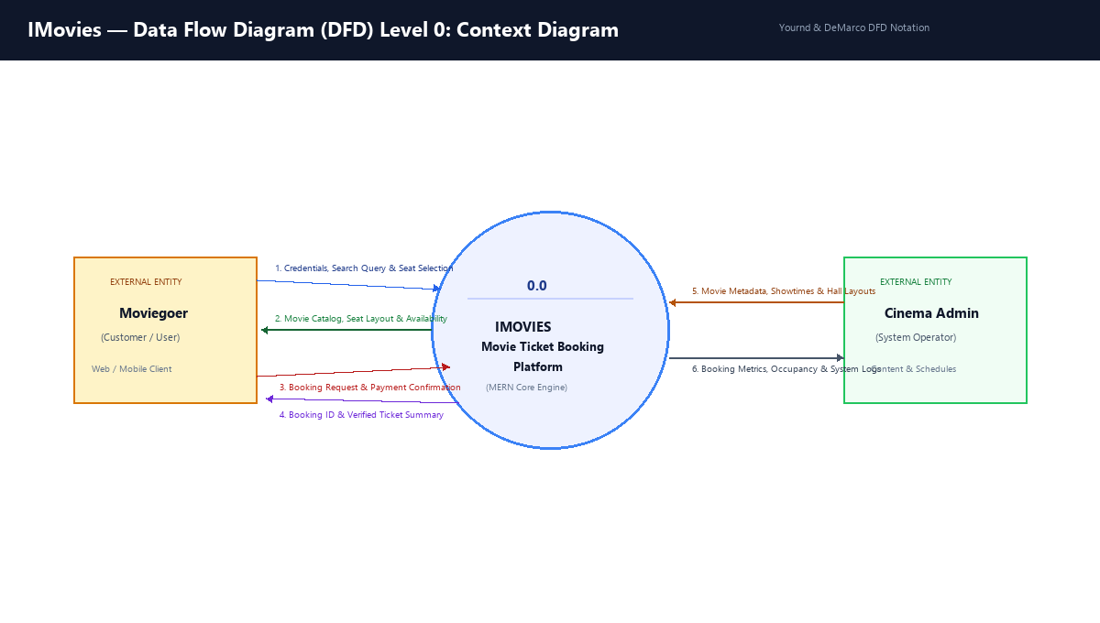
Figure 3.1: DFD Level 0 — IMovies System Context Diagram
DFD Level 1: Internal Process Decomposition Diagram
The Level 1 DFD decomposes the system into 5 primary internal processes and 4 discrete MongoDB data stores (Users, Movies, Showtimes, and Bookings):
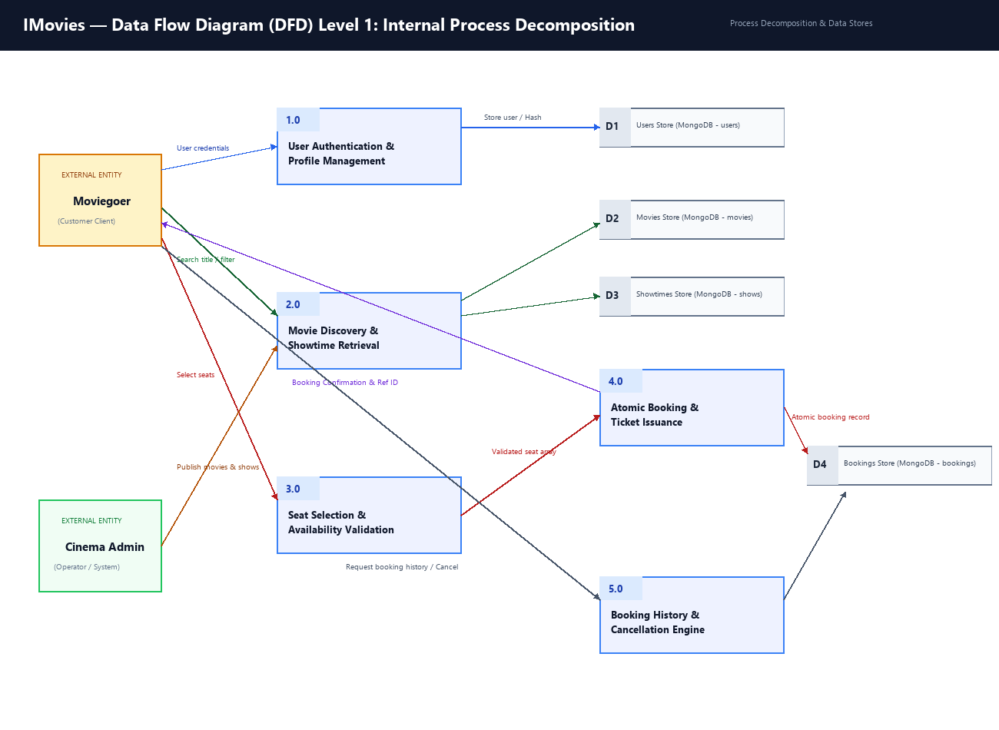
Figure 3.2: DFD Level 1 — Decomposition into Processes 1.0 to 5.0 and Data Stores D1 to D4
User Stories
User stories mapped to requirements, acceptance criteria, priority, and release sprint:
User Story Table — IMovies
User Type | Functional Requirement (Epic) | User Story / Task | Acceptance Criteria | Priority | Release
Moviegoer | User Authentication | As a user, I can register and login securely. | Successful account creation; JWT token stored; automatic session restoration. | High | Sprint-1
Moviegoer | Movie Discovery | As a user, I can search movies in real-time by title and filter by genre. | Instant client-side filter matching keyword without page reload. | High | Sprint-1
Moviegoer | Movie Details | As a user, I can view synopsis, runtime, rating, and watch trailer. | Detailed modal opens with movie poster, badges, and trailer playback. | Medium | Sprint-1
Moviegoer | Showtimes | As a user, I can view cinema halls and showtimes for selected movie. | Grouped display by cinema hall with morning, afternoon, and night pills. | High | Sprint-2
Moviegoer | Seat Selection | As a user, I can view an interactive seat grid and select available seats. | Clear visual distinction (gray: available, red: booked, green: selected); price tally updates. | High | Sprint-2
System | Concurrency Check | As a system, double-booking is prevented atomically at database level. | Overlapping seat reservations rejected with HTTP 409 Conflict. | High | Sprint-2
Moviegoer | Booking Creation | As a user, I can confirm booking and receive unique Booking Reference ID. | Booking stored in MongoDB; confirmation card rendered with full details. | High | Sprint-2
Moviegoer | Booking History | As a logged-in user, I can view my active and past bookings. | 'My Bookings' screen renders all user tickets sorted chronologically. | High | Sprint-3
Moviegoer | Booking Cancellation | As a user, I can cancel an active booking and release seats. | Booking status marked 'Cancelled' and seats restored to showtime inventory. | Medium | Sprint-3
Administrator | Catalog Management | As an admin, I can pre-seed realistic movies, theatres, and shows. | Seed script populates database with verified cinema data. | Medium | Sprint-1

